**VISVESVARAYA TECHNOLOGICAL UNIVERSITY BELAGAVI – 590 018**



**MINI PROJECT REPORT ON**

**“Employee Database Manager”**

Submitted In Partial Fulfillment of 6th semester WTA laboratory with Mini Project (18CS63)

**Bachelor of Engineering**

In

**Computer Science & Engineering**

**Submitted By:**

**Ajit (3GN20CS004)**

Under the guidance of

**Mr. SANDEEP IDDALGAVE**

**Asst. Professor**



**GURU NANAK DEV ENGINEERING COLLEGE**

**BIDAR-585401**

**Department of Computer Science & Engineering**

**Accredited by NBA, New Delhi**

**GURU NANAK DEV ENGINEERING COLLEGE**

**BIDAR-585401, KARNATAKA**

Approved by AICTE, New Delhi & Affiliated to VTU, Belagavi

Phone: 08482- 226949

Website:www.gndecb.ac.in



**DEPARTMENT OF COMPUTER SCIENCE AND ENGINEERING**

**CERTIFICATE**

This is to certify that the Mini Project Report entitled “**Employee Database Manager**” is a bonafide work carried out by **Ajit(3GN20CS004)**in partial fulfillment of the WTA Laboratory with Mini Project(18CS63) for 6th semester Bachelor of Engineering in Computer Science & Engineering during the year 2022-23. It is certified that all the corrections/suggestions indicated for Internal Assessment have been incorporated in the report deposited in the department library. The mini project has been approved as it satisfies the academic requirements in respect of laboratory work prescribed for the said degree.

**Signature of Guide**

**Prof. Sandeep Iddalgave**

**Employee Database Manager**

**1. HTML CODE**

<!DOCTYPE html>

<html lang="en">

  <head>

    <meta charset="UTF-8" />

    <meta name="viewport" content="width=device-width, initial-scale=1.0" />

    <title>Employee Database Management</title>

  </head>

  <body>

    <div id="app">

      <header class="header">

        <h1>Employee Database Management</h1>

        <button class="createEmployee">Add Employee</button>

      </header>

      <div class="employees">

        <div class="employees__names">

          <span class="employees__names--title">Employee List</span>

          <div class="employees__names--list"></div>

        </div>

        <div class="employees__single">

          <div class="employees__single--title">Employee Information</div>

          <div class="employees__single--info"></div>

        </div>

      </div>

*<!-- Add Employee Code - START -->*

      <div class="addEmployee">

        <form class="addEmployee_create">

          Add a new Employee

          <div>

            <input

              type="text"

              name="firstName"

              placeholder="First Name"

              required

            />

            <input

              type="text"

              name="lastName"

              placeholder="Last Name"

              required

            />

          </div>

          <input

            type="text"

            name="imageUrl"

            placeholder="Image URL (Optional)"

          />

          <input type="email" name="email" placeholder="Email" required />

          <input

            type="number"

            name="contactNumber"

            placeholder="Contact"

            required

          />

          <input type="number" name="salary" placeholder="Salary" required />

          <input type="text" name="address" placeholder="Address" required />

          <input

            type="date"

            name="dob"

            placeholder="Date of Birth"

            class="addEmployee_create--dob"

            required

          />

          <input

            type="submit"

            class="addEmployee_create--submit"

            value="Submit"

          />

        </form>

      </div>

*<!-- Add Employee Code - END -->*

    </div>

    <script src="src/script.js"></script>

    <link rel="stylesheet" href="./src/styles.css" />

  </body>

</html>

**2. CSS**

*/* Initial Structural CSS - START */*

:root {

  --btn: #dbdbdb;

  --btn-hover: #cacaca;

  --item-bg: #f0f0f0;

  --modal-bg: rgba(141, 141, 141, 0.541);

}

body {

  font-family: sans-serif;

  padding: 0 10px;

}

.header {

  display: flex;

  justify-content: space-between;

  align-items: center;

}

.header > button {

  padding: 10px 15px;

  border-radius: 20px;

  border: none;

  background-color: var(--btn);

  cursor: pointer;

}

.header > button:hover {

  background-color: var(--btn-hover);

}

.employees {

  display: flex;

}

.employees > div {

  border: 1px solid black;

  overflow-y: scroll;

  height: 450px;

}

.employees__names {

  width: 30%;

}

.employees__single {

  width: 70%;

}

.employees__names,

.employees__single {

  padding: 10px;

  display: flex;

  flex-direction: column;

}

.employees__names--title,

.employees__single--title {

  padding-bottom: 10px;

  margin-bottom: 5px;

  text-align: center;

  border-bottom: 1px solid black;

}

*/* Initial Structural CSS - END */*

*/* Render all Employees - START */*

.employees__names--list {

  display: flex;

  flex-direction: column;

}

.employees__names--item {

  cursor: pointer;

  padding: 10px 15px;

  margin-bottom: 5px;

  text-align: center;

  background-color: var(--item-bg);

  border-radius: 10px;

  display: flex;

  justify-content: space-between;

  align-items: center;

}

.employees__names--item:hover,

.selected {

  background-color: var(--btn);

}

*/* Render all Employees - END */*

*/* Render Single Employee - START */*

.employees__single--heading {

  text-align: center;

  font-size: 25px;

  text-transform: uppercase;

  padding: 5px;

}

.employees__single--info {

  display: flex;

  flex-direction: column;

  align-items: center;

  gap: 10px;

}

.employees__single--info > img {

  width: 250px;

  height: 250px;

  object-fit: contain;

  border-radius: 50%;

}

*/* Render Single Employee - END */*

*/* Add Employee - START */*

.addEmployee {

  display: none;

  width: 100%;

  height: 100%;

  position: absolute;

  top: 0;

  left: 0;

  justify-content: center;

  align-items: center;

  background-color: var(--modal-bg);

}

.addEmployee_create {

  width: 400px;

  background-color: white;

  box-shadow: 0 0 50px grey;

  padding: 20px;

  border-radius: 5px;

  text-align: center;

  display: flex;

  flex-direction: column;

  gap: 15px;

}

.addEmployee_create > div {

  display: grid;

  grid-template-columns: 48.1% 48.1%;

  column-gap: 15px;

}

.addEmployee_create input {

  padding: 5px 10px;

  border-radius: 5px;

  border: 1px solid rgb(236, 236, 236);

}

*/* removes arrows from input type='number' */*

.addEmployee_create input::-webkit-outer-spin-button,

.addEmployee_create input::-webkit-inner-spin-button {

  -webkit-appearance: none;

  margin: 0;

}

.addEmployee_create--submit {

  padding: 10px !important;

  border-radius: 5px;

  border: none;

  background-color: var(--btn);

  cursor: pointer;

}

.addEmployee_create--submit:hover {

  background-color: var(--btn-hover);

}

3. JAVASCRIPT

(async function () {

  const data = await fetch("./src/data.json");

  const res = await data.json();

  let employees = res;

  let selectedEmployeeId = employees[0].id;

  let selectedEmployee = employees[0];

  const employeeList = document.querySelector(".employees__names--list");

  const employeeInfo = document.querySelector(".employees__single--info");

*// Add Employee - START*

  const createEmployee = document.querySelector(".createEmployee");

  const addEmployeeModal = document.querySelector(".addEmployee");

  const addEmployeeForm = document.querySelector(".addEmployee_create");

  createEmployee.addEventListener("click", () => {

    addEmployeeModal.style.display = "flex";

  });

  addEmployeeModal.addEventListener("click", (*e*) => {

    if (e.target.className === "addEmployee") {

      addEmployeeModal.style.display = "none";

    }

  });

*// Set Employee age to be entered minimum 18 years*

  const dobInput = document.querySelector(".addEmployee_create--dob");

  dobInput.max = `${new Date().getFullYear() - 18}-${new Date()

    .toISOString()

    .slice(5, 10)}`;

  addEmployeeForm.addEventListener("submit", (*e*) => {

    e.preventDefault();

    const formData = new FormData(addEmployeeForm);

    const values = [...formData.entries()];

    let empData = {};

    values.forEach((*val*) => {

      empData[val[0]] = val[1];

    });

    empData.id = employees[employees.length - 1].id + 1;

    empData.age =

      new Date().getFullYear() - parseInt(empData.dob.slice(0, 4), 10);

    empData.imageUrl =

      empData.imageUrl || "https://cdn-icons-png.flaticon.com/512/0/93.png";

    employees.push(empData);

    renderEmployees();

    addEmployeeForm.reset();

    addEmployeeModal.style.display = "none";

  });

*// Add Employee - END*

  employeeList.addEventListener("click", (*e*) => {

*// Select Employee Logic - START*

    if (e.target.tagName === "SPAN" && selectedEmployeeId !== e.target.id) {

      selectedEmployeeId = e.target.id;

      renderEmployees();

      renderSingleEmployee();

    }

*// Select Employee Logic - END*

*// Employee Delete Logic - START*

    if (e.target.tagName === "I") {

      if (confirm("Do you Want Delete Employee")) {

        employees = employees.filter(

          (*emp*) => String(emp.id) !== e.target.parentNode.id

        );

        if (String(selectedEmployeeId) === e.target.parentNode.id) {

          selectedEmployeeId = employees[0]?.id || -1;

          selectedEmployee = employees[0] || {};

          renderSingleEmployee();

        }

        renderEmployees();

      }

    }

*// Employee Delete Logic - END*

  });

*// Render All Employees Logic - START*

  const renderEmployees = () => {

    employeeList.innerHTML = "";

    employees.forEach((*emp*) => {

      const employee = document.createElement("span");

      employee.classList.add("employees__names--item");

      if (parseInt(selectedEmployeeId, 10) === emp.id) {

        employee.classList.add("selected");

        selectedEmployee = emp;

      }

      employee.setAttribute("id", emp.id);

      employee.innerHTML = `${emp.firstName} ${emp.lastName} <i class="employeeDelete">❌</i>`;

      employeeList.append(employee);

    });

  };

*// Render All Employees Logic - END*

*// Render Single Employee Logic - START*

  const renderSingleEmployee = () => {

*// Employee Delete Logic - START*

    if (selectedEmployeeId === -1) {

      employeeInfo.innerHTML = "";

      return;

    }

*// Employee Delete Logic - END*

    employeeInfo.innerHTML = `

      <img src="${selectedEmployee.imageUrl}" />

      <span class="employees__single--heading">

      ${selectedEmployee.firstName} ${selectedEmployee.lastName} (${selectedEmployee.age})

      </span>

      <span>${selectedEmployee.address}</span>

      <span>${selectedEmployee.email}</span>

      <span>Mobile - ${selectedEmployee.contactNumber}</span>

      <span>DOB - ${selectedEmployee.dob}</span>

    `;

  };

*// Render Single Employee Logic - END*

  renderEmployees();

  if (selectedEmployee) renderSingleEmployee();

})();

**4. OUTPUT**

**4.1 Employee Data**

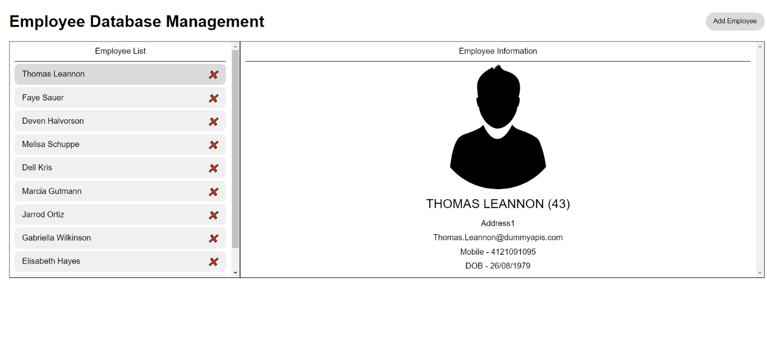

*Fig: employee data*

4.2 Adding Employee Data

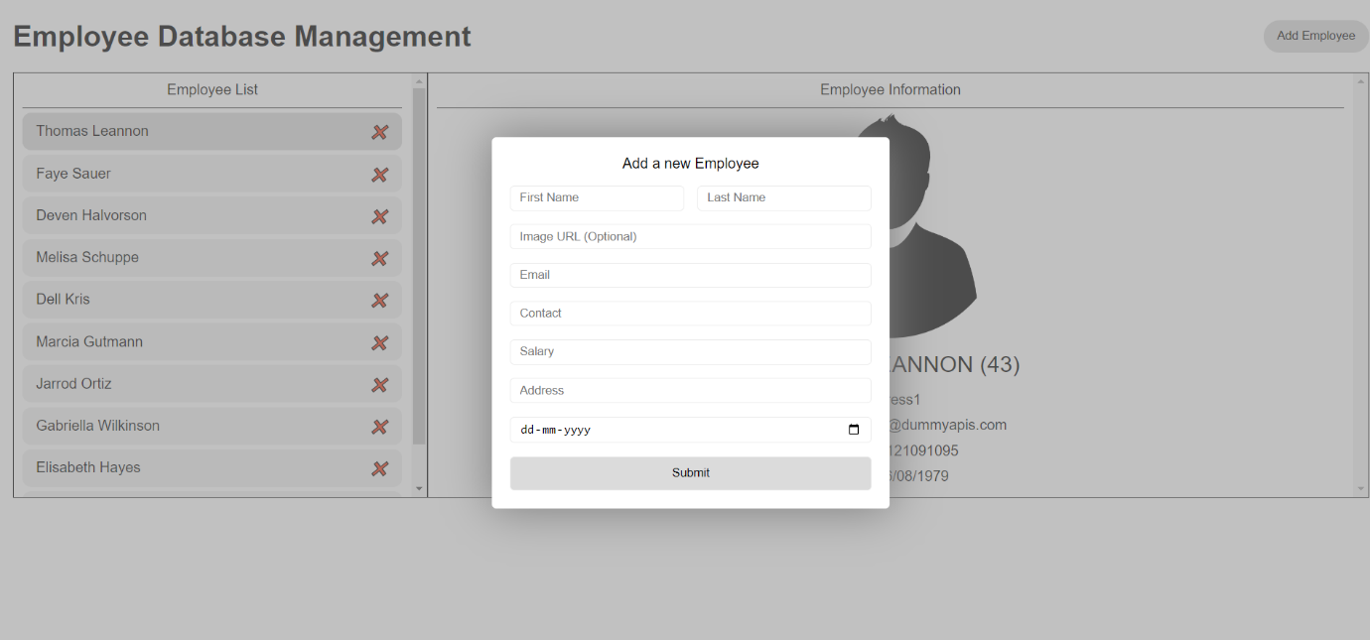

*Fig: employee data Form*